Govt. Polytechnic Manesar, Gurugram (Automobile Engg. Deptt.)
(Study Material Helpful for Students )
Garage Location and Layout
An automobile repair shop may also be known regionally as a garage or a workshop, is an establishment where automobiles are repaired by auto mechanics and technicians.

SERVICE STATION :
A service is a place where in addition to care of the motor vehicle like mechanical service and minor repairs, petrol is supplied, cars are lubricated, cleaned, washed and other types pf simpler services that are required daily are performed. In general it includes a number of sections like garage general services, mechanical service, major repair shop, tyre shop, paint shop, body shop etc.
A service station is addition to the equipment available is garage is usually run in conjuction with a sales agency for a particular type of motor vehicle to provide comprehensive repair service for that particular vehicle.
The equipment available, in general garage will be added with specialized equipment like lifting tackle, and different types of jigs, fixtures and tools specially designed for checking, adjusting and repair of particular type and make of vehicle. A service station may consist of a machine shop having a lathe, drilling machine etc.
In case of big service station special types of machines like crankshaft grinding machine, valve refacer, surface grinder, reboring and boring machine, brake drum lathe also will be used. In service station fuel filling and water servicing facilities are available. It has a small workshop to provide repair for particular make of vehicle. It may have sales agency for a particular type of vehicle. All the equipment in the garage plus small workshop tools: viz, lathe, drilling machine, jigs, fixtures are available.

LAYOUT OF GARAGES AND SERVICE STATION :
The internal layout of a garage should be in a way as to make it water proof, clean and spacious to provide sufficient space for small workbenches to storage and repair benches. Following considerations should be made in the layout of garage and service stations:
- To provide light to the workbenches, openings the windows should be provided at the proper place.
- To keep the floor cleanable, it should be a smooth concrete floor with a surface-scaling compound.
- The doors are provided as many members as required for easy flow of men and materials.
- The electrical control should be accessible to the operators.
- To form a neat storage for hanging tools, hooks or screw eyes should be provided on the pegboards.
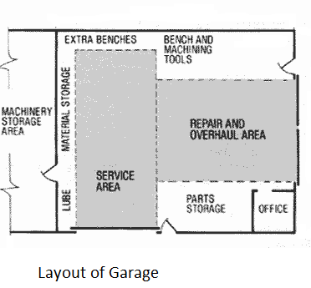

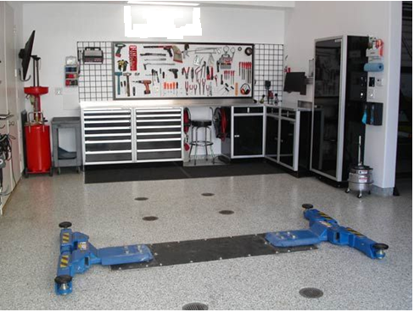
Modern Garage Tools / Inside

